**Project:**

**Radha Store**

**E-commerce Annual Sales Analysis Report**

**2022**

Content

* Problem Statement
* Business Problems / Analytical Goals
* Solution Approach
  + Step-1: Understanding Source data and analytical goals
  + Step-2: Data Cleaning
  + Step-3: Data processing
  + Step-4: Data Analysis
  + Step-5: Data Visualization/Dashboarding
* Final Dashboard Report (Screenshots)
* Derived Insights
* Problem Statement

**Radha store** is an E-commerce store with many products to sell in various categories. They are available on different online e-commerce platforms across India, like Amazon, Flipkart, Meesho, etc  
  
Now, they want to create an annual sales report for 2022. So that they can analyse their performance in terms of sales, the report should communicate to them about their customers' purchasing behaviour and patterns.  
  
Therefore they hire you as a data analyst, and you must create their E-commerce Annual sales report for 2022. They will provide you with their sales data for 2022, along with their business problems which you should consider as analytical goals while developing this report using **MS Excel**.

* Business Problems / Analytical Goals

1. Which month got the highest and lowest sales in 2022?
2. Monthly sales trend ($) and the number of orders placed in 2022.
3. How many percent are men and women in our total customer base by 2022?
4. Detail % distribution of orders according to order status, like-  
   What is the % orders that are successful deliveries?  
   What is the % orders that get cancelled?  
   What is the % orders raised refund requests?  
   What is the % orders that get returned, etc?
5. What are the top 5 product categories in terms of sales?  
   And how much % is their contribution to total revenue?
6. What are the top 5 states in terms of sales ($)? What is the % contribution in the total sale of each respective state?
7. What is the % distribution of total orders across different age groups, also how many % are men and women in each age group?
8. How many sales ($) did we get close through each channel?

All the data should be filterable for different months, cities, platforms/channels, and product categories.

* Solution Approach

**Step 1: Understanding Source data and analytical goals**

The first and most important thing is to understand the given raw data based on the business problems we going to solve. The company’s business problems should be considered as analytical goals that will be implemented while creating the dashboard report.

**Step 2: Data Cleaning**

The next step we going to approach is cleaning the provided raw data, as the data may probably contain null values, empty values, or values that may be inconsistent in some columns.

For example. the Quantity column contains values: 1, 2, 3, 4, … and “one”, “two” etc.

Once we clean our raw data and transform it into a consistent set of data, we can consider it as our source data further.

**Step 3: Data Processing**

In the step of data processing, we tend to perform some sort of data calculations and derive some new columns that will be required for making analysis.

To conclude which set of columns we should calculate and add to the source data, we need to make observations about the source data and the analytical goals. Whether there is any information gap that should be filled.

Example:

1. In the source data we have the ‘date’ column, however, according to the problem set ‘month name’ column is required.
2. Source data has the column ‘Age’, but during the analysis, we need an ‘Age group’ Column.
3. If we have given the price of the product and quantity ordered, we will calculate the revenue/ order price for every order.
4. Extracting elements from an ‘address’ column like, pin code, city, state, etc.

Once we add up all the crucial derived columns to the source data we have done with data processing and we are good to go for the next step.

**Step 4: Data Analysis**

This is the most exciting part of our project where we will bring our data to life by creating visualization elements bar graphs, pie charts slicer elements, and timeline elements, by implementing pivot charts.

The selection of appropriate visualization charts is a crucial task, it is dependent on the analytical problem statements/ goals trying to cater

**Step 5: Data Visualizations / Dashboarding**

After validating our analytical values, we created the dashboard by putting all the created individual pivot charts together.

* **Visualization Charts**

1. Monthly Trend- Revenue vs Orders

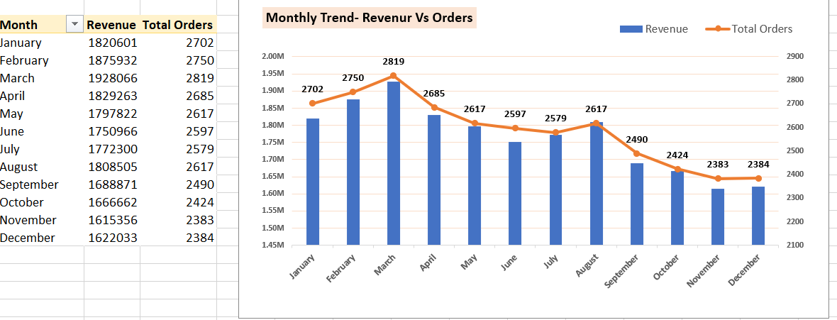

1. Total orders- Men vs Women

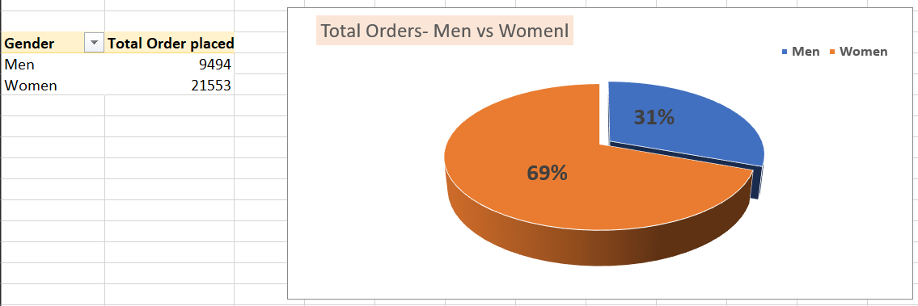

3. Order Status

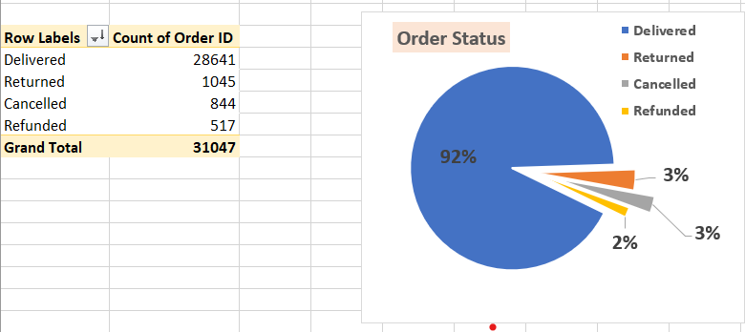

4. Top 5 states for Sales ($)

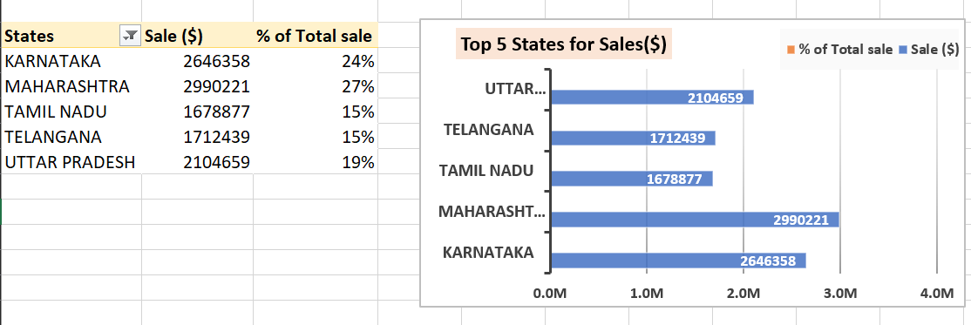

1. Age vs Gender- Order Distribution

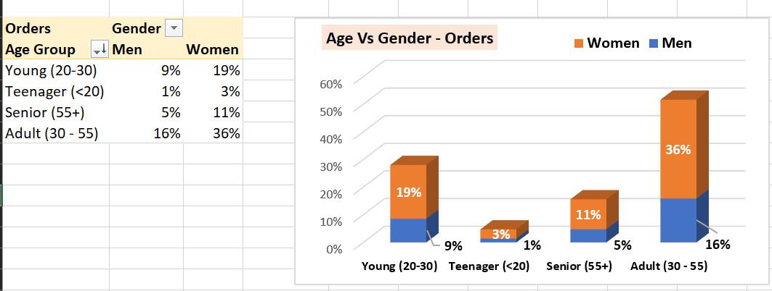

1. Sales ($) by different Channels

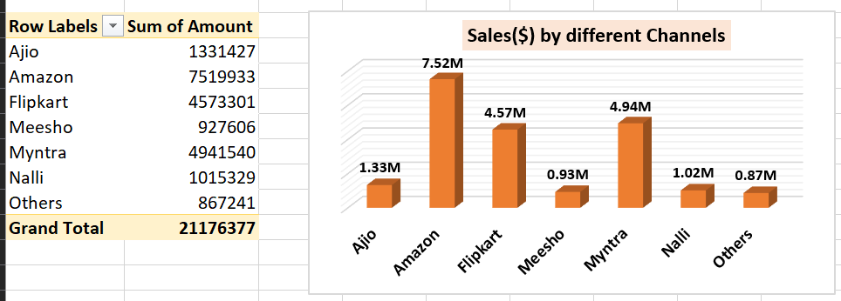

1. Top 5 Product Categories by Orders, and Their Revenue %

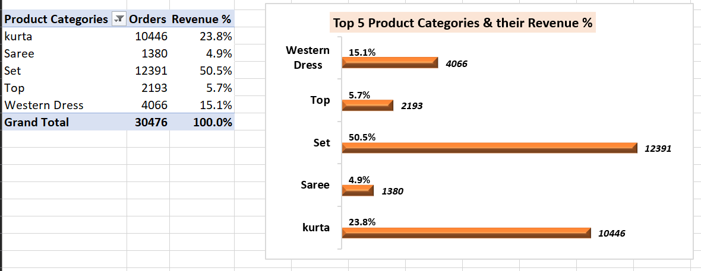

* Final Report Dashboard

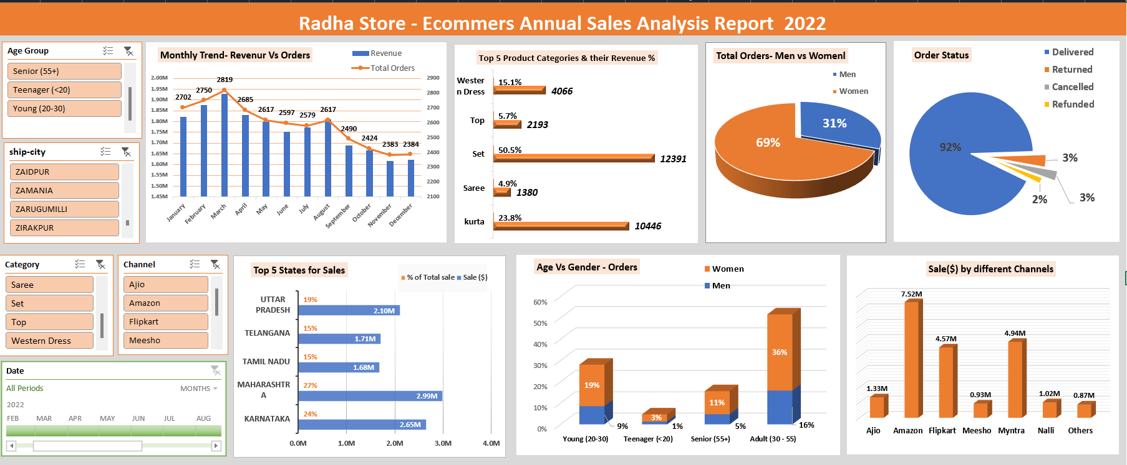

After applying filters-

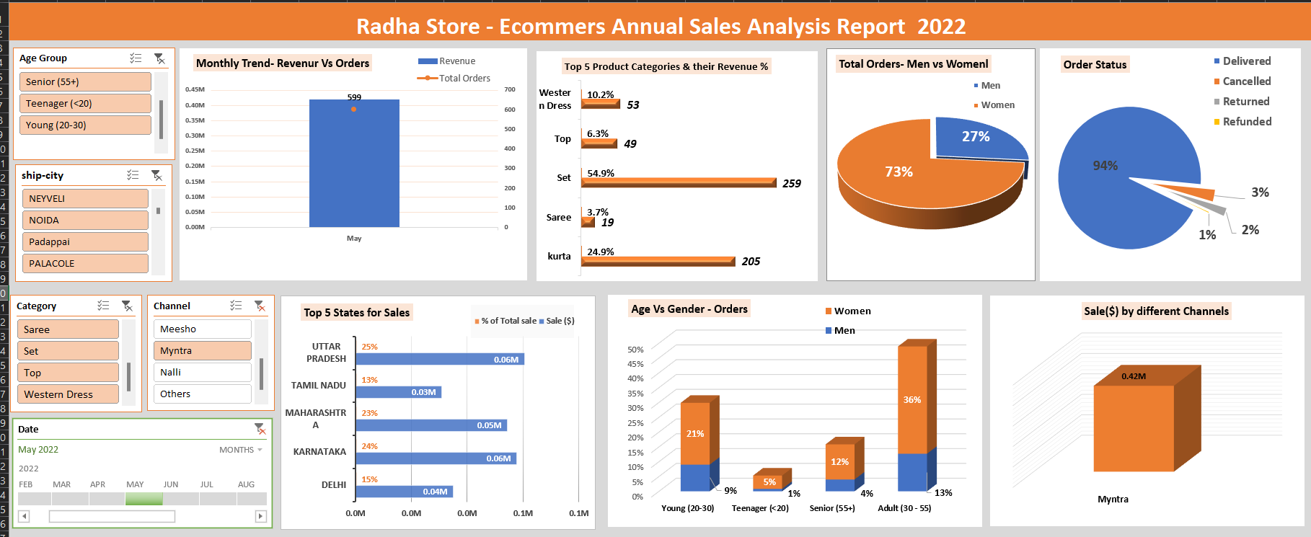

* Derived Insights

1. The first 3 months of the year are best performing and the last 3 months of the year are least performing in terms of sales and Revenue.

month with-

Highest sale = March (Revenue: Rs.1.92Mn)

Least Sale = November (Revenue: Rs.1.61Mn)

**# Recommendation:**

To promote an increase in sales at year-end we can provide Extra discounts coupons, and special offers combos.

2. In your customer base 70% almost are women and 30% are men.

**#Recommendation:**

To increase the male customer base, we should introduce some strategies, like- special combos, Gift vouchers, movie tickets, etc

3. In the orders

successful deliveries = 92%

Returned = 3%

Cancelled = 3%

Refunded = 2%

4. Top 5 product Categories by sale-

Westen Dress (Revenue % = 15%)

Set (Revenue % = 50%)

Kurta (Revenue % =24%)

Top (Revenue % = 6%)

Saree (Revenue % =5%)

**#Recommendation:**

Try to focus on these top categories to increase potential sales, by up stocking these category products with the latest fashion Trends having competitive pricing or premium quality.

5. Top 5 States in terms of Revenue-

1. Maharashtra (Revenue = Rs. 2.99M) - 27% of total Revenue

2. Karnataka (Revenue = Rs. 2.65M) - 24% of total Revenue

3. Uttar Pradesh (Revenue = Rs. 2.1M) - 19% of total Revenue

4. Telangana (Revenue = Rs. 1.71M) - 15% of total Revenue

5. Tamil Nadu (Revenue = Rs. 1.68M) - 15% of total Revenue

6. Total order Segregation across Age group vs Gender-

Teenager (<20) = 1%M + 3%W = 4% of total orders

Young (20-30) = 9%M + 19%W = 28% of total orders

Adult (31-55) =16%M + 36%W = 52% of total orders

Senior (>55) =5%M + 11%W = 16% of total orders

**#Recommendation:**

Almost 70% of your customer base belongs to the Adult and Senior age groups combined, therefore target this segment of products, and there is potential growth in sales.

7. Top 3 Channels/platforms of E-commerce in terms of Revenue-

1. Amazon (Revenue= Rs. 7.5M)

2. Myntra (Revenue= Rs. 4.9M)

3. Flipkart (Revenue=Rs. 4.5M)

**#Recommendation:**

Server your best quality products and quick customer support on these top 3 E-commerce platforms. Only these 3 platforms generated 80% of total sales alone (almost Rs. 17M out of Rs. 21 M)

----------------------------------------------------------------------------